Soulslike game in Unity – Daniel Trandafir

Sprint 3 realisation

Table of Contents

**Introduction** 1

**I.** **Inventory system** 1

**1.** **World Item Database** 2

**2.** **Weapon Model Instantiation Slot** 2

**3.** **Player Equipment Manager** 3

**II.** **Attacking and dealing damage** 5

**1.** **Weapon Items** 5

**2.** **Weapon Item Actions** 6

**3.** **Player Combat Manager** 6

**III.** **Network synchronisation** 7

IV. Conclusion 8

# **Introduction**

The purpose of this document is to provide a more detailed analysis of the progress I made with my personal project during the third sprint. In this phase of my project, I focused mostly on designing the inventory system, allowing the player to equip a weapon. Alongside this, I added attack animations, colliders for the player and weapon model, and revised network synchronisation. Thus, in this report I will go into more depth into these features I implemented and showcase them visually, as well as go over what my next steps are for the following sprints.

# **Inventory system**

Almost all RPGs have an inventory system, and the souls series is, of course, no exception. The inventory system allows the player to interact with the different items, weapons, and armour that the developers decide to implement in the game. The soulslike inventory has become a staple of the industry. Essentially, it is split into the “equipment” screen and the actual “inventory” screen. Equipment represents the items that the player has active and can use during combat, most often visually represented with a D-pad style interface in the bottom left corner of the screen, while the inventory is the place where all the player’s items are stored, regardless of their useability in combat.

My focus this sprint was on designing the code and framework for such a system. Equipping an item is done through the Unity’s editor interface for now, but it can easily be extended in the future to be part of the player’s UI.

## **World Item Database**

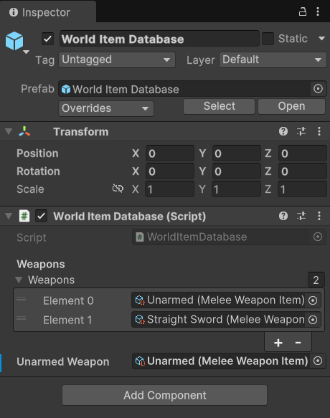

Image 01 – World Item Database

This is a very simple script whose entire purpose is to store all the items in the game and return them by ID. Currently, it only has 2 weapons, “*Unarmed*” and “*Straight Sword*”

## **Weapon Model Instantiation Slot**

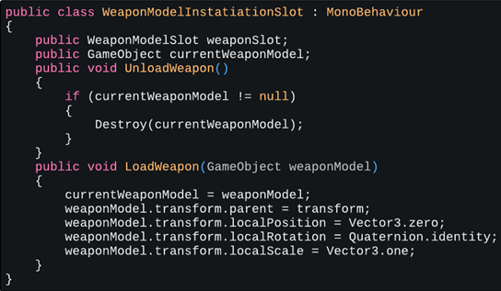

Image 02 – Weapon Model Instantiation Slot script

This script is attached to the player prefab’s hands and serves the very simple purpose of setting the weapon model’s transform when it gets instantiated. It has an Enum variable to determine if the script is attached to the player’s right or left hand.

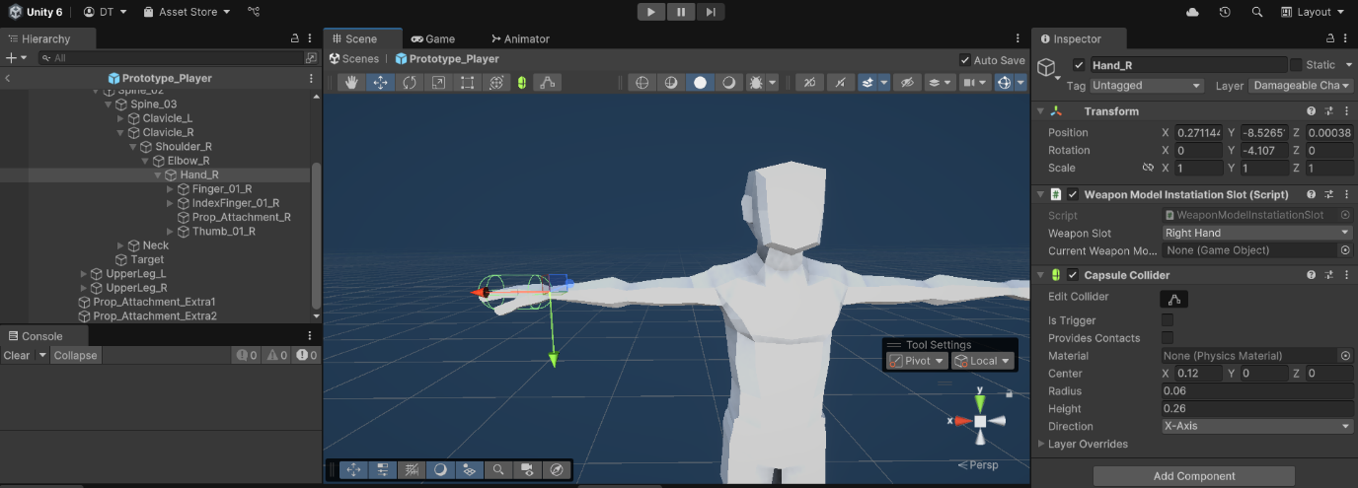

Image 03 – Script attached to the player prefab’s right hand

## **Player Equipment Manager**

This is where the player equips the weapon on his right-hand or left-hand weapon slot, just like in classic Dark Souls fashion.

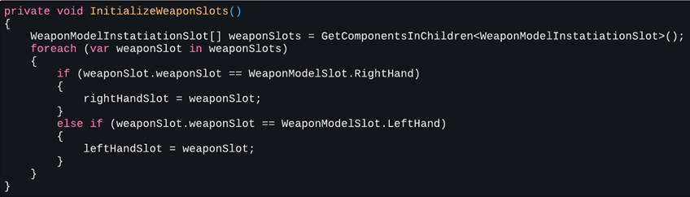

Image 03 – **Initialize Weapon Slots method**

This method, which is called on awake, simply initializes the weapon slots variables inside the Weapon Model Instantiation Slot script.

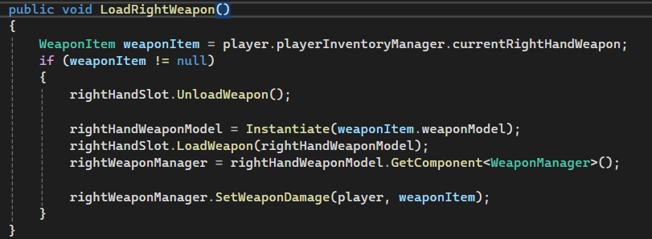

Image 04 – **Load Right Weapon method**

Called mainly from the Player Network Manager script when subscribing to events that make the player equip the weapon. Gets called once in the Player Equipment Manager, but because the Weapon Item variable is initially null, it simply loads *“Unarmed”.*

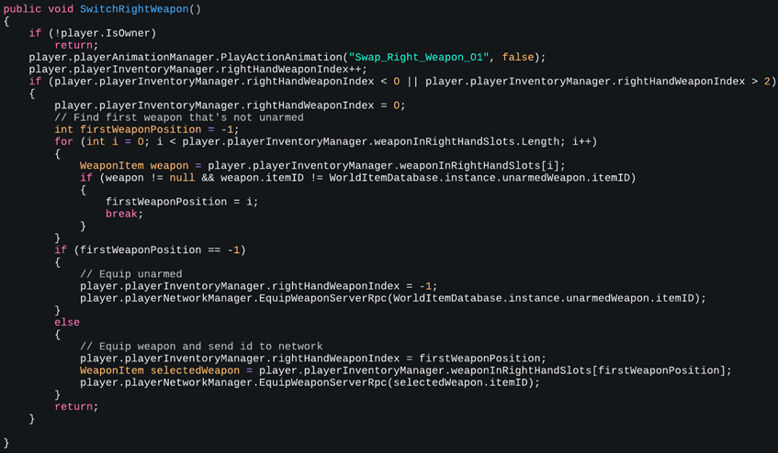

Image 05 – First half of **Switch Right Weapon** method

This recursive method has the main functionality of looping through the player equipment slots, finding the first weapon that is not unarmed, and switching to it. Both this method and **Load Right Weapon** have an identical copy for the player’s left hand.

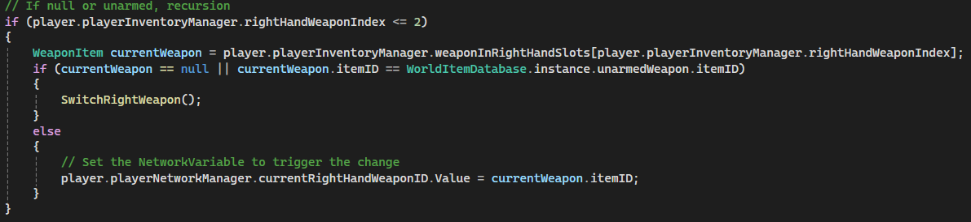

Image 06- Second half of **Switch Right Weapon** method

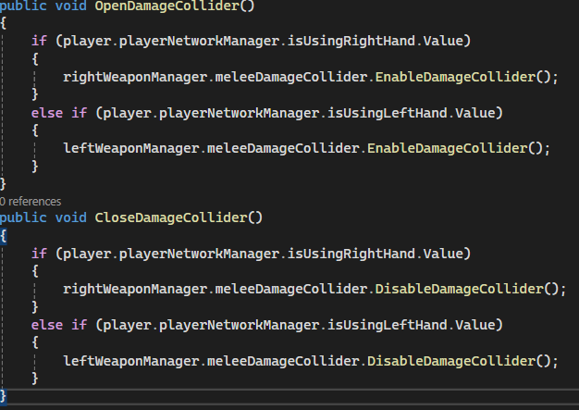

Image 07 – Opening and closing **Damage Colliders**

Both methods are called using the animation events system, the former when the attack begins, and the latter when it ends.



Video 01 – Attack animation and events in the **Unity Animator**

# **Attacking and dealing damage**

I designed the player “actions” as scriptable objects inside Unity, the same way I created and stored the data for the items, such as the *Straight Sword*, or the instant effects, such as the *Take Health Damage Effect.*

1. **Weapon Items**: Items like the *Straight Sword* have “actions” variables, in which their possible actions are stored as scriptable objects.

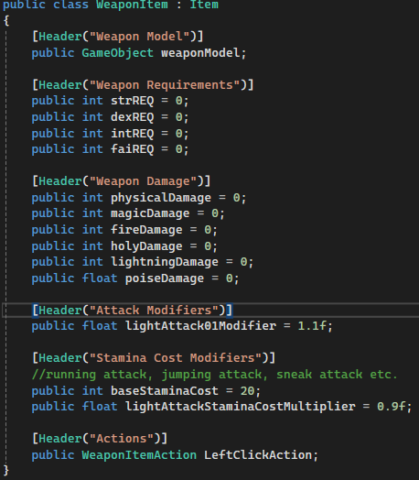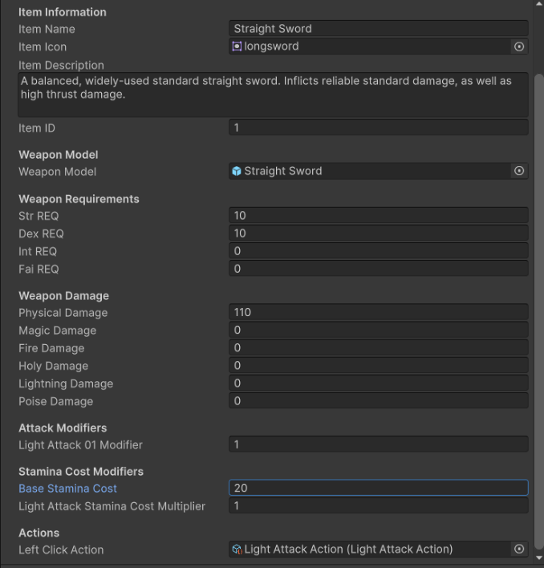

Image 08 – **Weapon Item** scriptable object, in code and in the Inspector

1. **Weapon Item Actions**: Performs the action and plays the animations if certain conditions are met. For example, the player must have enough stamina to be able to perform an attack. Such checks are performed here.

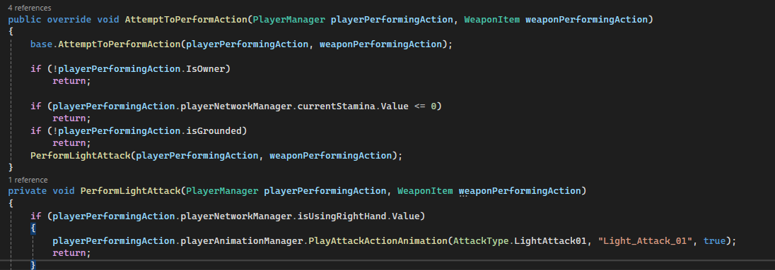

Image 09 – **Light Attack Action** scriptable object

1. **Player Combat Manager**: Attached to the player prefab. Works in tandem with the **Player Input Manager** to begin the action sequence and notify the server, using RPCs, of the weapon action. Also contains a method for deducting stamina on attacks, called at the same time as **Open Damage Collider** in the animation event system.

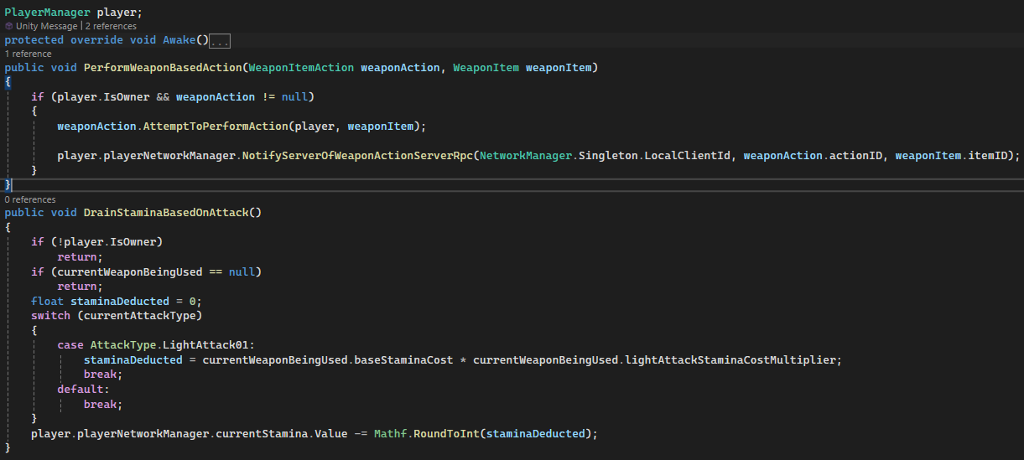

Image 10 – **Player Combat Manager** script

# **Network synchronisation**

I have revised the way RPCs are sent to the server and the clients, as well as linked all the new systems to function smoothly on the network. Whereas before the RPCs went sent to all, the functionalities have now been split so the system is easier to expand and understand for future development.

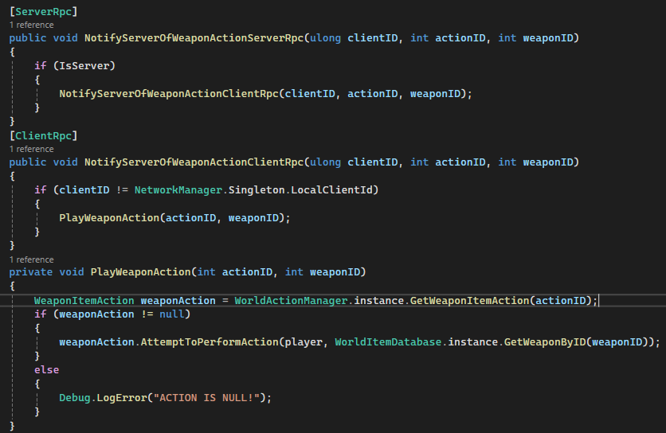

Image 11 – RPCs for sending Weapon Actions in the **Player Network Manager**

I also updated the On Network Spawn method of the Player Manager to account for the new weapon and equipment system.

And finally, the end result:



Video 02: Player character equipping weapon and attacking



Video 03 – Host player attacking client player. Syncing animations, client takes damage

# **Conclusion**

Compared to previous sprints, I have not done as much work for my personal project, but that is not due to negligence or a problem I encountered, it’s simply been caused by a change of focus. I did a lot more work for the group project instead, and didn’t have as much time for my own game. Nevertheless, I achieved what I had in mind, and will continue putting in the same ammount of effort as before. Next, I want to implement the lock-on system for combat and add an enemy AI for the player to fight.